INDOOR CLASSIC TRACK MEET
TECHNICAL PACKAGE
Date: Saturday, February 8, 2019 Time: 9:00am-5:00pm
Location: Family Leisure Centre, 2000 Division Avenue N, Medicine Hat, Alberta
Hosted by: Medicine Hat Panthers Track & Field Club
Private Meet
Websites: www.medhatpantherstrackclub.ca Email medhatpanthers@gmail.com
Categories: Age as of December 31 the year of competition
MINI: 6 & Under (born in 2014/2015) | Tyke: 9 years of age & under (born in 2011 or later) | PeeWee: 10 & 11 years of age (born in 2009-2010) | Bantam: 12 & 13 years of age (born in 2007-2008) | Midget: 14 & 15 years of age (born in 2005-2006)
Youth: 16 & 17 years of age (born in 2003-2004) | Junior: 18 & 19 years of age (born in 2001-2002) | Senior: 20+ years of age (born in 2000 or earlier) | Masters: 35+ years of age (born in 1985 or earlier) | Masters +:65+ years of age (born in 1955 or earlier)

Events Offered:
60m | All ages | 150m | 13 & under
200m | 14 & older | 400m | 16 & older
800m | All ages except MINI | 1200m | 12-15 years
1500m | 16 & older | 4x200m Relay | All Ages, except MINI
3000m | 15 & older | 60mHurdles | Bantam/Midget/Youth/Junior
 |  | Predictive Race | Senior/Open/Masters/Masters+

Relay registration will be held on day of event by 12:00pm
Schedules: Tentative schedules are posted on the website. Final schedules will be posted the day before the competition.
Please NOTE: Races many run with combined age divisions, but scored separately.
Day of Meet Entries: Will only be accepted at Meet Directors’ discretion and if space is available (Cost is $20 – cash only)
Awards: Ribbons will be awarded for each event 1st, 2nd, 3rd, 4th & 5th place standings.
T-Shirts: Pre-order, by Jan 27th. Are available for sale at registration table
Entry Fees:
$15 per athlete per event (received on or before February 5, 2020) or 3/$40
$20 per athlete per event (received AFTER February 5, 2020)
Make cheques payable to Medicine Hat Panthers Track & Field Club
Starting Blocks:
Athletes competing in the Midget (14 & 15 years of age) and older age category will be will be required to use starting blocks for the following events: 60m, 200m, 400m.
Athletes who are not affiliated with a club team will have the choice to opt-out of using starting blocks.
Spikes: Spikes must be pyramids or Christmas trees. 3mm or less spikes only allowed on track surface FOR MEET ONLY.
Athletics Alberta Membership:
This is meet is not sanctioned through Athletics Alberta and is a local training meet. Local records will be kept, however no records or rankings at a Provincial or National level can be achieved through this meet.
Results: Results will be posted by registration table and will be posted to the website a week after the meet is completed (www.medhatpantherstrackclub.ca)

Panthers Indoor Classic Procedures 2020
REGISTRATION
Athletes or Coaches must pay registration fees at the Registration Table prior to competition.
MARSHALLING
1. Athletes must confirm their entry at the Registration Table no later than 20 minutes prior to the start of their event.
2. Athletes must be at the start line 10 minutes prior to their event.
3. Relays Teams, or interest in joining a relay team, must be submitted to the Registration Table no later than 10:00 am. The age category of the team will be determined by the oldest member of the team (except with masters athletes).

SPECTATORS/ATHLETES
Space is always limited on an indoor track. Spectators/athletes must be aware of what is going on at all times.
Spectators are asked to cross the track quickly, between races. When spectators are on the track they must be aware of athletes warming up and/or competing.
Athletes and Spectators must stay off of the fitness training equipment.
RACE/HEAT SHEETS AND RESULTS
Heat Sheets and results will be posted in the spine of the Leisure Center, near the Registration Table.
START PROCEDURES
60m: All age categories will have timed finals for 60m.
150m/200m: All age groups will run the complete race in lanes. All race are timed finals
400m: Youth and older will run the first 2 corners in lanes and then cut-in. All races are timed finals
800m and longer: Waterfall start or one Corner stagger at the discretion of the Meet Director and the Starters. All races are timed finals
2020 Panthers Indoor Classic – 800 (lanes) 1200 (lanes) 1500 (waterfall) 3000 (waterfall)
Predictive 800m Race: NO WATCHES OR TIMING DEVICES
Must submit predictive race time 1 week prior to the Indoor Classic, Feb.1st – to medhatpanthers@gmail.com. Score is the difference between the submitted time and the actual time.

Hurdles:
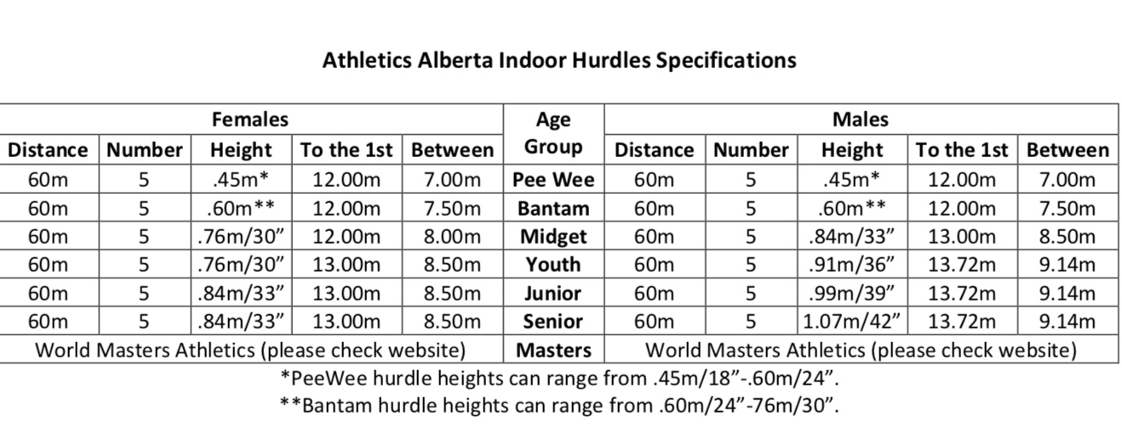

Relay procedures:
4x200 Relay
The first runner will run in their assigned lane and hand off to the second runner, who will run the 1st corner of their leg in their assigned lane and then cut in at the start of the back stretch.

